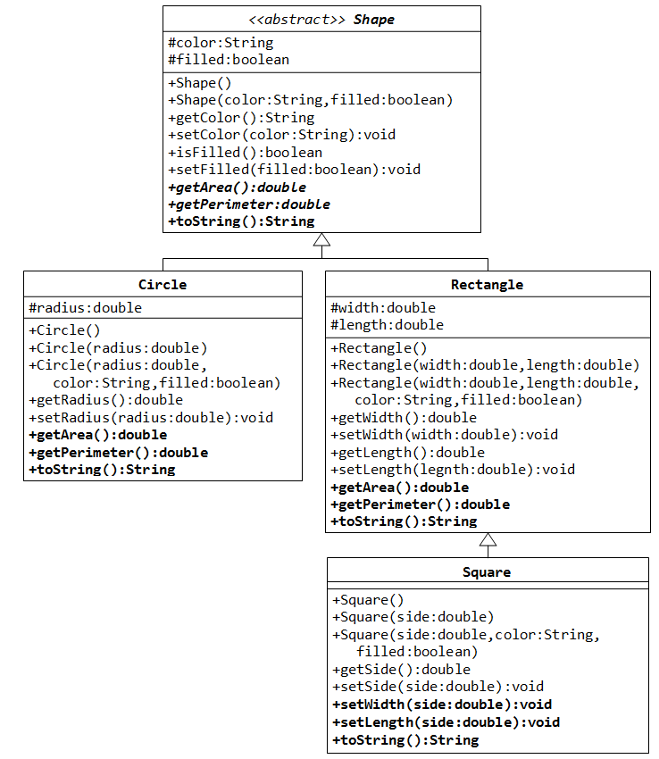

Exercise: Abstract Superclass Shape and Its Concrete Subclasses
Rewrite the superclass Shape and its subclasses Circle, Rectangle and Square, as shown in the class diagram.

Write a superclass called Shape (as shown in the class diagram), which contains:
- Two instance variables color (String) and filled (boolean).
- Two constructors: a no-arg (no-argument) constructor that initializes the color to "green" and filled to true, and a constructor that initializes the color and filled to the given values.
- Getter and setter for all the instance variables. By convention, the getter for a boolean variable xxx is called isXXX() (instead of getXxx() for all the other types).
- A toString() method that returns "A Shape with color of xxx and filled/Not filled".
Write a test program to test all the methods defined in Shape.
Write two subclasses of Shape called Circle and Rectangle, as shown in the class diagram.
The Circle class contains:
- An instance variable radius (double).
- Three constructors as shown. The no-arg constructor initializes the radius to 1.0.
- Getter and setter for the instance variable radius.
- Methods getArea() and getPerimeter().
- Override the toString() method inherited, to return "A Circle with radius=xxx, which is a subclass of yyy", where yyy is the output of the toString() method from the superclass.
The Rectangle class contains:
- Two instance variables width (double) and length (double).
- Three constructors as shown. The no-arg constructor initializes the width and length to 1.0.
- Getter and setter for all the instance variables.
- Methods getArea() and getPerimeter().
- Override the toString() method inherited, to return "A Rectangle with width=xxx and length=zzz, which is a subclass of yyy", where yyy is the output of the toString() method from the superclass.
Write a class called Square, as a subclass of Rectangle. Convince yourself that Square can be modeled as a subclass of Rectangle. Square has no instance variable, but inherits the instance variables width and length from its superclass Rectangle.
- Provide the appropriate constructors (as shown in the class diagram). Hint:
public Square(double side) {
super(side, side); // Call superclass Rectangle(double, double)
}
- Override the toString() method to return "A Square with side=xxx, which is a subclass of yyy", where yyy is the output of the toString() method from the superclass.
- Do you need to override the getArea() and getPerimeter()? Try them out.
- Override the setLength() and setWidth() to change both the width and length, so as to maintain the square geometry.

In this exercise, Shape shall be defined as an abstract class, which contains:
- Two protected instance variables color(String) and filled(boolean). The protected variables can be accessed by its subclasses and classes in the same package. They are denoted with a '#' sign in the class diagram.
- Getter and setter for all the instance variables, and toString().
- Two abstract methods getArea() and getPerimeter() (shown in italics in the class diagram).
The subclasses Circle and Rectangle shall override the abstract methods getArea() and getPerimeter() and provide the proper implementation. They also override the toString().
Write a test class to test these statements involving polymorphism and explain the outputs. Some statements may trigger compilation errors. Explain the errors, if any.
Shape s1 = new Circle(5.5, "RED", false); // Upcast Circle to Shape
System.out.println(s1); // which version?
System.out.println(s1.getArea()); // which version?
System.out.println(s1.getPerimeter()); // which version?
System.out.println(s1.getColor());
System.out.println(s1.isFilled());
System.out.println(s1.getRadius());

Circle c1 = (Circle)s1; // Downcast back to Circle
System.out.println(c1);
System.out.println(c1.getArea());
System.out.println(c1.getPerimeter());
System.out.println(c1.getColor());
System.out.println(c1.isFilled());
System.out.println(c1.getRadius());

Shape s2 = new Shape();

Shape s3 = new Rectangle(1.0, 2.0, "RED", false); // Upcast
System.out.println(s3);
System.out.println(s3.getArea());
System.out.println(s3.getPerimeter());
System.out.println(s3.getColor());
System.out.println(s3.getLength());

Rectangle r1 = (Rectangle)s3; // downcast
System.out.println(r1);
System.out.println(r1.getArea());
System.out.println(r1.getColor());
System.out.println(r1.getLength());

Shape s4 = new Square(6.6); // Upcast
System.out.println(s4);
System.out.println(s4.getArea());
System.out.println(s4.getColor());
System.out.println(s4.getSide());

// Take note that we downcast Shape s4 to Rectangle,
// which is a superclass of Square, instead of Square
Rectangle r2 = (Rectangle)s4;
System.out.println(r2);
System.out.println(r2.getArea());
System.out.println(r2.getColor());
System.out.println(r2.getSide());
System.out.println(r2.getLength());

// Downcast Rectangle r2 to Square
Square sq1 = (Square)r2;
System.out.println(sq1);
System.out.println(sq1.getArea());
System.out.println(sq1.getColor());
System.out.println(sq1.getSide());
System.out.println(sq1.getLength());

What is the usage of the abstract method and abstract class?

