https://www3.ntu.edu.sg/home/ehchua/programming/java/J3f_OOPExercises.html

Ex: Polymorphism
Examine the following codes and draw the class diagram.
abstract public class Animal {
abstract public void greeting();
}
public class Cat extends Animal {
@Override
public void greeting() {
System.out.println("Meow!");
}
}
public class Dog extends Animal {
@Override
public void greeting() {
System.out.println("Woof!");
}

public void greeting(Dog another) {
System.out.println("Woooooooooof!");
}
}
public class BigDog extends Dog {
@Override
public void greeting() {
System.out.println("Woow!");
}

@Override
public void greeting(Dog another) {
System.out.println("Woooooowwwww!");
}
}
Explain the outputs (or error) for the following test program.
public class TestAnimal {
public static void main(String[] args) {
// Using the subclasses
Cat cat1 = new Cat();
cat1.greeting();
Dog dog1 = new Dog();
dog1.greeting();
BigDog bigDog1 = new BigDog();
bigDog1.greeting();

// Using Polymorphism
Animal animal1 = new Cat();
animal1.greeting();
Animal animal2 = new Dog();
animal2.greeting();
Animal animal3 = new BigDog();
animal3.greeting();
Animal animal4 = new Animal();

// Downcast
Dog dog2 = (Dog)animal2;
BigDog bigDog2 = (BigDog)animal3;
Dog dog3 = (Dog)animal3;
Cat cat2 = (Cat)animal2;
dog2.greeting(dog3);
dog3.greeting(dog2);
dog2.greeting(bigDog2);
bigDog2.greeting(dog2);
bigDog2.greeting(bigDog1);
}
}
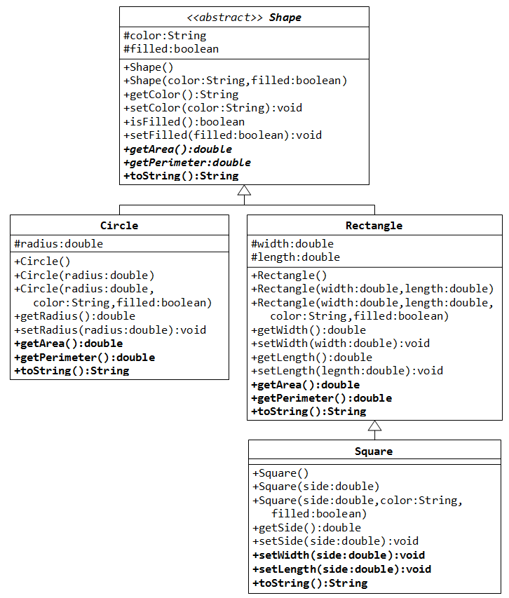
In this exercise, Shape shall be defined as an abstract class, which contains:
- Two protected instance variables color(String) and filled(boolean). The protected variables can be accessed by its subclasses and classes in the same package. They are denoted with a '#' sign in the class diagram.
- Getter and setter for all the instance variables, and toString().
- Two abstract methods getArea() and getPerimeter() (shown in italics in the class diagram).
The subclasses Circle and Rectangle shall override the abstract methods getArea() and getPerimeter() and provide the proper implementation. They also override the toString().
Write a test class to test these statements involving polymorphism and explain the outputs. Some statements may trigger compilation errors. Explain the errors, if any.
Shape s1 = new Circle(5.5, "RED", false); // Upcast Circle to Shape
System.out.println(s1); // which version?
System.out.println(s1.getArea()); // which version?
System.out.println(s1.getPerimeter()); // which version?
System.out.println(s1.getColor());
System.out.println(s1.isFilled());
System.out.println(s1.getRadius());

Circle c1 = (Circle)s1; // Downcast back to Circle
System.out.println(c1);
System.out.println(c1.getArea());
System.out.println(c1.getPerimeter());
System.out.println(c1.getColor());
System.out.println(c1.isFilled());
System.out.println(c1.getRadius());

Shape s2 = new Shape();

Shape s3 = new Rectangle(1.0, 2.0, "RED", false); // Upcast
System.out.println(s3);
System.out.println(s3.getArea());
System.out.println(s3.getPerimeter());
System.out.println(s3.getColor());
System.out.println(s3.getLength());

Rectangle r1 = (Rectangle)s3; // downcast
System.out.println(r1);
System.out.println(r1.getArea());
System.out.println(r1.getColor());
System.out.println(r1.getLength());

Shape s4 = new Square(6.6); // Upcast
System.out.println(s4);
System.out.println(s4.getArea());
System.out.println(s4.getColor());
System.out.println(s4.getSide());

// Take note that we downcast Shape s4 to Rectangle,
// which is a superclass of Square, instead of Square
Rectangle r2 = (Rectangle)s4;
System.out.println(r2);
System.out.println(r2.getArea());
System.out.println(r2.getColor());
System.out.println(r2.getSide());
System.out.println(r2.getLength());

// Downcast Rectangle r2 to Square
Square sq1 = (Square)r2;
System.out.println(sq1);
System.out.println(sq1.getArea());
System.out.println(sq1.getColor());
System.out.println(sq1.getSide());
System.out.println(sq1.getLength());
What is the usage of the abstract method and abstract class?

